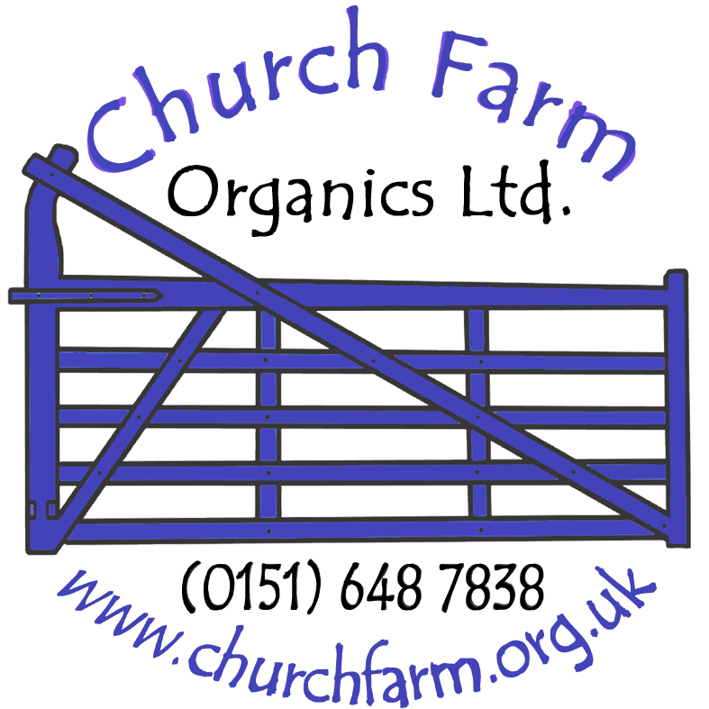 |  | Church Farm School Visit  Risk Assessment |  | Assessor: Matthew Ledsham | Position: Events Manager | Date: Feb 07
 |  | Church Farm, Church Lane, Thurstaston, Wirral, CH61 0HW |  | Verified By: Jon Bentley | Position: Farm Manager | Date: Feb 07
 | Hazard Observed |  | Groups at risk | Control Measures |  | Risk rating after controls
1 | Weather conditions- the visit is primarily outdoors and teachers / parents are reminded that all children must arrive in suitable clothing and footwear for the outdoor conditions. |  | Visitors & staff | Advice given to visitors before visit so they can ensure the correct clothing is worn. Covered trailers to be used. During visit conditions to be monitored by farm staff and visit curtailed in severe weather conditions. |  | LOW
2 | Child Protection |  | Pupils | CRB where deemed appropriate by Farm Management |  | LOW
3 | Machinery- potential injury due to moving parts or falling from moving machinery. |  | Visitors & staff | Areas where visitors are not permitted to be illustrated at start of visit. Children to be supervised at all times to ensure they do not play on or around farm equipment. Strict instruction to be followed on entrance and exit of trailer and whilst on board- children to remain seated at all times. |  | LOW
4 | Animals- can be unpredictable in their behaviour and can bite or knock-over unwary people. |  | Visitors & staff | Visitors to follow guidance at times regarding safe areas and conduct around farm animals. Visitors instructed not to enter or approach animal areas unless supervised and instructed by authorised farm staff. |  | LOW
5 | Farm Environs- potential infection from micro-organisms present in all animals. Can cause illness of infection if ingested |  | Visitors & staff | Hand cleaning facilities with anti-bacterial soap solution. Brief by staff to instruct everyone about possible hazards and the importance of washing hands before contact with food. Pregnant women to avoid animal contact. Children to be told not to put fingers in mouths. |  | LOW
6 | Allergic Reactions- animals can trigger allergic reactions from their coat, feathers or fur. In addition animal beddings such as straw and hay can contain pollen. |  | Visitors & staff | School visit organisers to be aware of allergies within the group and instruct farm staff to ensure allergen avoidance where possible. |  | LOW
7 | Surfaces- risk of slipping on muddy paths or in fields especially under wet conditions. |  | Visitors & staff | All visitors to keep to paths with supervision given to children on steps at all times. |  | LOW
8 | Lost Children |  | Pupils | Teachers to conduct head counts before and after each activity to ensure group is complete |  | LOW
9 | Play Area- risk of falls & bumps |  | Pupils | Pupils to be permitted to area only with strict control and supervision. |  | LOW
Risk Priority: Low- accident unlikely with control measures in place
This assessment of risk is for all those engaged on pre-booked guided school visits to Church Farm. A farm visit presents hazards through its’ working farm environment and the associated hazards of farm animals, tools and machinery. This risk assessment may be used as part of the overall risk assessment compiled for the visit by the visit organiser.

